Chapter 3 Consumer Behavior

• Topics to be Discussed
- Consumer Preferences
- Budget Constraints
- Consumer Choice
- Revealed Preferences
- Marginal Utility and Consumer Choices

• Consumer Behavior
There are three steps involved in the study of consumer behavior.
- We will study consumer preferences.
- To describe how and why people prefer one good to another.
- Then we will turn to budget constraints.
- People have limited incomes.
- Finally, we will combine consumer preferences and budget constraints to determine consumer choices.
  - What combination of goods will consumers buy to maximize their satisfaction?

• Consumer Preferences
- A market basket is a collection of one or more commodities.
- One market basket may be preferred over another market basket containing a different combination of goods.

• Consumer Preferences
Three Basic Assumptions
- Preferences are complete.
- Preferences are transitive.
- Consumers always prefer more of any good to less.
- Along an indifference curve there is a diminishing marginal rate of substitution.

• Consumer Preferences
- Indifference curves represent all combinations of market baskets that provide the same level of satisfaction to a person.
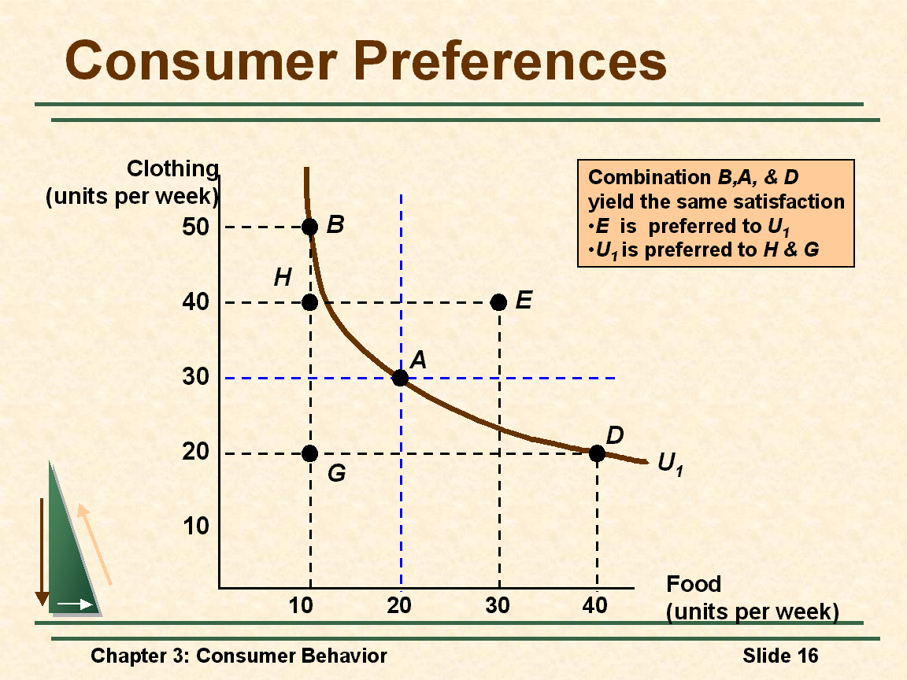

• Indifference Curves
- Indifference curves slope downward to the right.
- If it sloped upward it would violate the assumption that more of any commodity is preferred to less.
- Any market basket lying above and to the right of an indifference curve is preferred to any market basket that lies on the indifference curve.

• Consumer Preferences
- An indifference map is a set of indifference curves that describes a person’s preferences for all combinations of two commodities.
- Each indifference curve in the map shows the market baskets among which the person is indifferent.
- Finally, indifference curves cannot cross. This would violate the assumption that more is preferred to less.

• Consumer Preferences
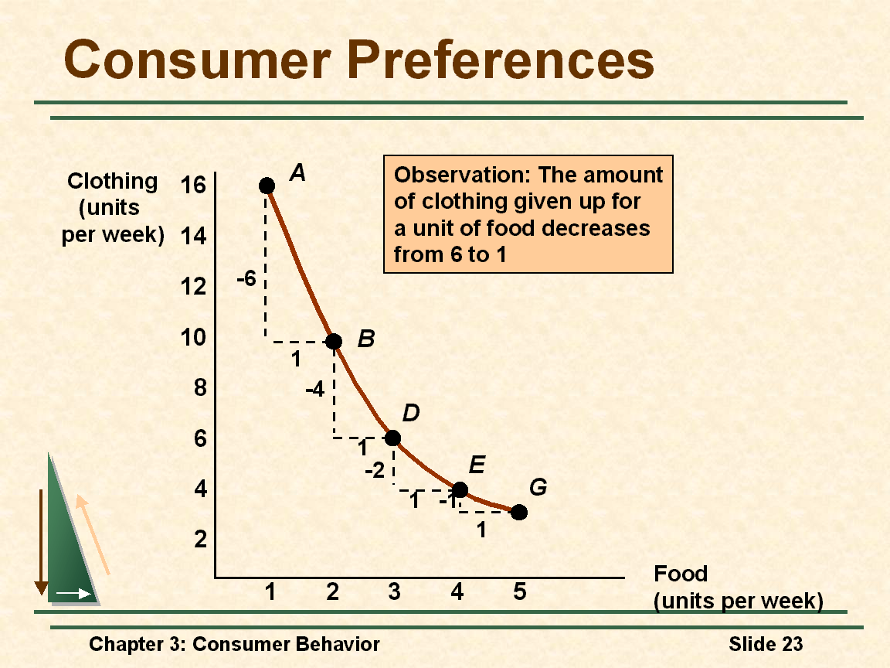

- The marginal rate of substitution (MRS) quantifies the amount of one good a consumer will give up to obtain more of another good.
- It is measured by the slope of the indifference curve.
  - MRS = 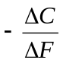
- We will now add a fourth assumption regarding consumer preference:
  - Along an indifference curve there is a diminishing marginal rate of substitution.
- Note the MRS for AB was 6, while that for DE was 2.

• Consumer Preferences
- Indifference curves are convex because as more of one good is consumed, a consumer would prefer to give up fewer units of a second good to get additional units of the first one.
• Perfect Substitutes and Perfect Complements
- Two goods are perfect substitutes when the marginal rate of substitution of one good for the other is constant.
- Two goods are perfect complements when the indifference curves for the goods are shaped as “L”.

• Utility
- Utility: Numerical score representing the satisfaction that a consumer gets from a given market basket.
- If buying 3 copies of Microeconomics makes you happier than buying one shirt, then we say that the books give you more utility than the shirt.

• Utility Functions
Assume: The utility function for food (F) and clothing (C)

U(F,C) = F + 2C
Market Baskets: F units C units U(F,C) = F + 2C
A 8 3 8 + 2(3) = 14
B 6 4 6 + 2(4) = 14
C 4 4 4 + 2(4) = 12
- The consumer is indifferent to A & B
- The consumer prefers A & B to C

Consumer Preferences
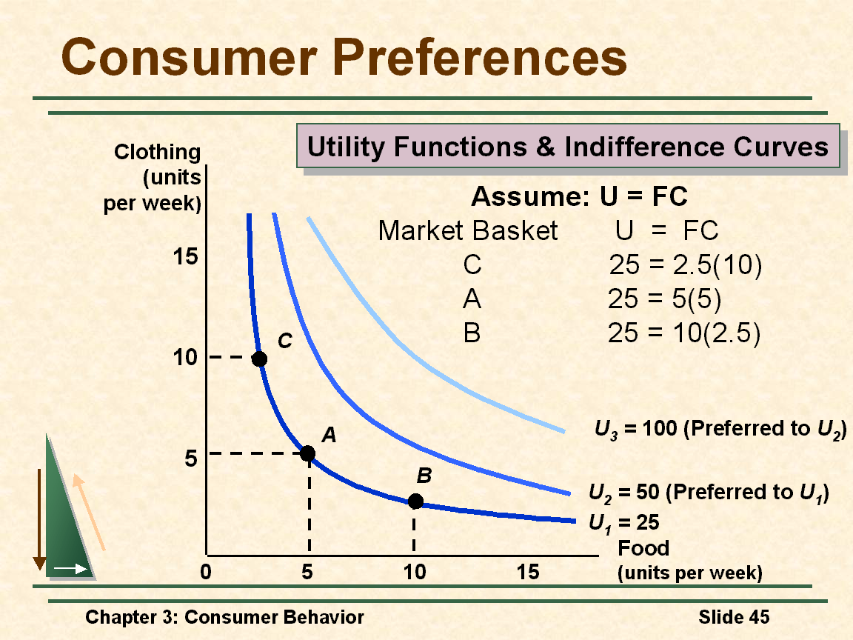
• Ordinal Versus Cardinal Utility
- Ordinal Utility Function: places market baskets in the order of most preferred to least preferred, but it does not indicate how much one market basket is preferred to another.
- Cardinal Utility Function: utility function describing the extent to which one market basket is preferred to another.

• Budget Constraints
- Preferences do not explain all of consumer behavior.
- Budget constraints also limit an individual’s ability to consume in light of the prices they must pay for various goods and services.

• Budget Line
- The budget line indicates all combinations of two commodities for which total money spent equals total income.
- Let F equal the amount of food purchased, and C is the amount of clothing.
  - Price of food = P_{F} and price of clothing = P_{C}
  - Then P_{F}F is the amount of money spent on food, and P_{C}C is the amount of money spent on clothing.
- The budget line then can be written:
P_{F}F + P_{C}C = Income

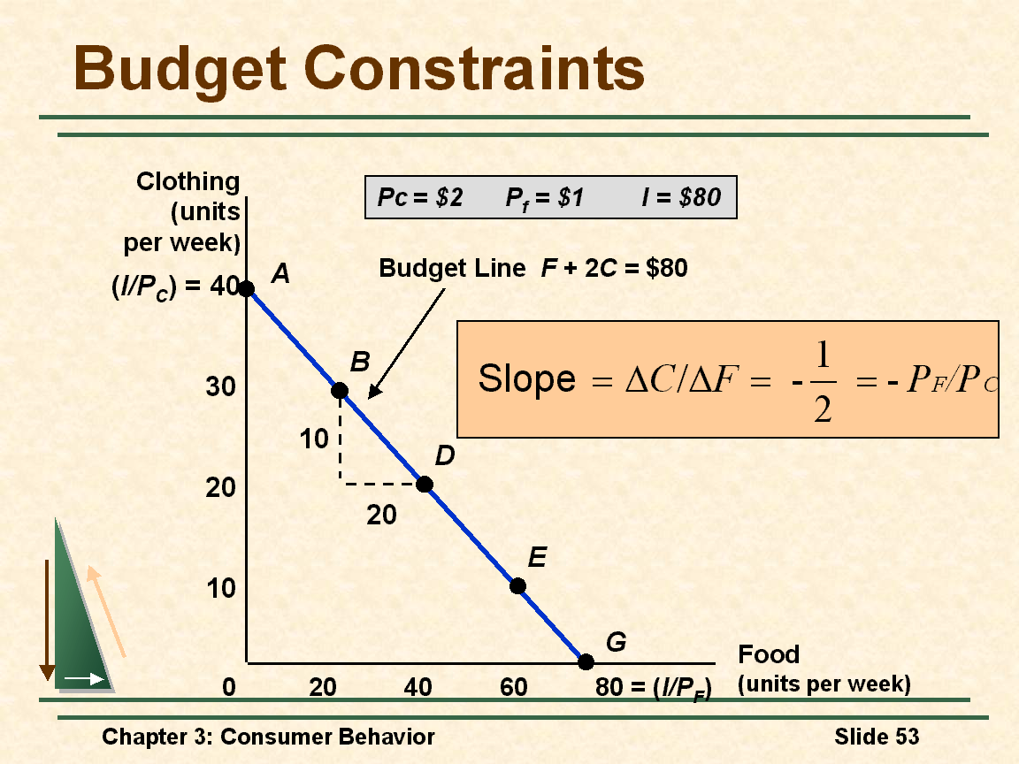

- The slope of the line measures the relative cost of food and clothing.
- The slope is the negative of the ratio of the prices of the two goods.

• The Effects of Changes in Income and Prices
- Income Changes
  - An increase in income causes the budget line to shift outward, parallel to the original line (holding prices constant).
- Price Changes
  - If the price of one good increases, the budget line shifts inward, pivoting from the other good’s intercept.
  - If the two goods increase in price, but the ratio of the two prices is unchanged, the slope will not change.

• Consumer Choice
- Consumers choose a combination of goods that will maximize the satisfaction they can achieve, given the limited budget available to them.
- The maximizing market basket must satisfy two conditions:
  - It must be located on the budget line.
  - Must give the consumer the most preferred combination of goods and services.
- Recall, the slope of an indifference curve is: MRS =
- The slope of the budget line is 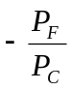
- Therefore, it can be said that satisfaction is maximized where:
- MRS = =
- It can be said that satisfaction is maximized when marginal rate of substitution (of F and C) is equal to the ratio of the prices (of F and C).

• Consumer Choice
- A corner solution exists if a consumer buys in extremes, and buys all of one category of good and none of another.
- This exists where the indifference curves are tangent to the horizontal and/or vertical axis.
- MRS is not equal to the relative price ratio of two products.

• Marginal Utility and Consumer Choice
- Marginal utility measures the additional satisfaction obtained from consuming one additional unit of a good.
- The principle of diminishing marginal utility states that as more and more of a good is consumed, consuming additional amounts will yield smaller and smaller additions to utility.

• Marginal Utility and the Indifference Curve
- If consumption moves along an indifference curve, the additional utility derived from an increase in the consumption one good, food (F), must balance the loss of utility from the decrease in the consumption in the other good, clothing (C).
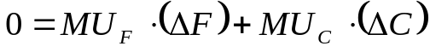
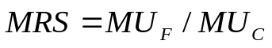
- When consumers maximize satisfaction,
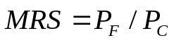

  - Total utility is maximized when the budget is allocated so that the marginal utility per dollar of expenditure is the same for each good.
  - This is referred to as the equal marginal principle.

